1: Leeson Introduktion

Link:

Notes:

**Introduction to the Cloud and AWS**

Welcome to this lesson on Introduction to the Cloud and AWS. You'll learn about the cloud infrastructure ecosystem and understand how to use essential tools for computing, storage, and analytics through one of the biggest providers of cloud computing, Amazon Web Services.

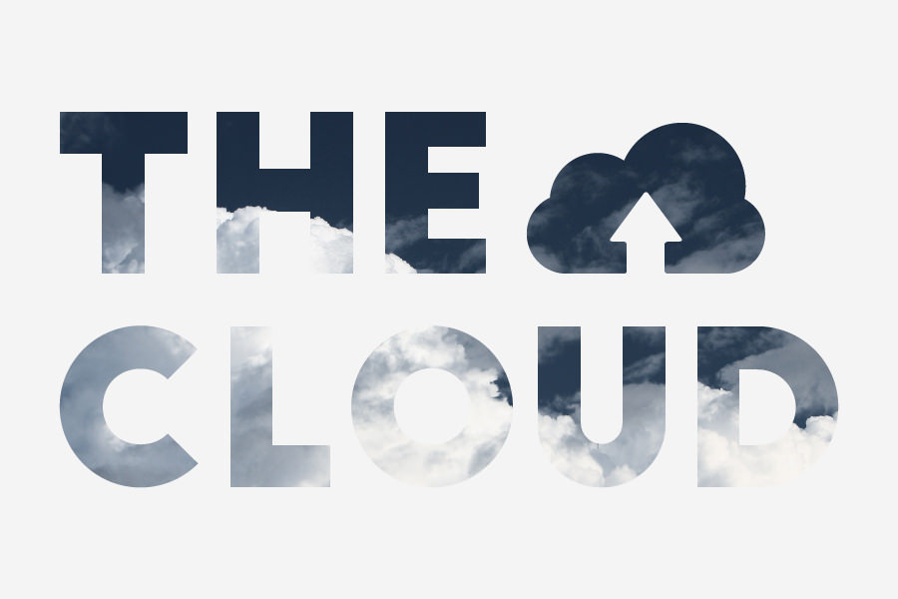

2: Cloud Computing

Link: <https://www.youtube.com/watch?v=Eq3nFasSiqA>

Notes:

**What Is Cloud Computing?**

**Cloud computing:**the practice of using a network of remote servers hosted on the Internet to store, manage, and process data, rather than a local server or a personal computer.

The arrival of cloud computing completely changed the way we deploy our technology, providing powerful access to instant and scalable computing power to enterprises, startups, and developers alike. Whether you need servers to host a web application, reliable storage for your data, or machines to train machine learning models, it's easy to see the advantage of relying on the cloud rather than utilizing your personal computer or local servers.

For one, you no longer have to invest in lots of hardware upfront. No need to worry about whether you are paying for more than you'll need or what to do if you need to scale a lot more later on. Cloud computing makes this as easy and clicking a few buttons to scale your resources up or down.

It's significantly faster provisioning the resources you need through the cloud versus the time it would take to gather and build up the hardware you'd need to provide the same support. This allows you and your team, or company, to develop and experiment at a much faster rate.

Lastly, you can provide efficient access to your applications around the world by spreading your deployments to multiple regions.

NEXT

3: Amazon Web services

Link: <https://www.youtube.com/watch?v=06IxCvhMhPw>

Notes:

# Amazon Web Services

Amazon Web Services is one of the largest providers in the cloud computing industry, with over 140 services in compute, storage, databases, networking, developer tools, security, and more. In this lesson, we'll learn about a few essential tools and services in AWS and practice using them. These services can be accessed in three different ways: the AWS Management Console, the Command Line Interface (CLI), or Software Development Kits (SDKs), which can be used in combination.

We'll start with the AWS Management Console, which is the web user interface. The AWS CLI is a useful way to control and automate your services with code, and SDKs allow you to easily integrate services with your applications through APIs built around specific languages and platforms.

4: AWS account setting

Link:

Notes:

### Step 1. Create an AWS Account

Open a regular AWS account (if you don't already have one) following the instructions via the [**Amazon Web Service Help Center**](https://aws.amazon.com/premiumsupport/knowledge-center/create-and-activate-aws-account/)

### Step 2. Get Promo Codes

Udacity has partnered with AWS to provide nominal credits for learners whose coursework requires AWS services to complete. To request a promo code, you can submit a Support ticket [**here**](https://udacity.zendesk.com/hc/en-us/requests/new?ticket_form_id=110806).

1. Under the **"Reason for Contact"** field, choose **"Third-Party Access, Promo Codes & License keys**", then choose **"AWS"** in the dropdown.

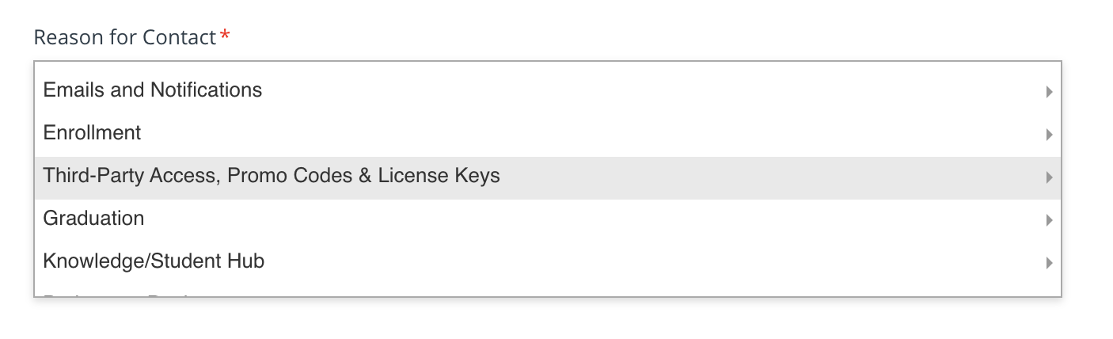

Snapshot: **Reason for Contact** field.

1. Please note that a regular AWS account will receive a promo code from Udacity with a fixed amount of AWS credits.

### Step 3. Apply Promo Code to Your AWS Account

To apply your promo code, follow below:

1. Go to the [**AWS Billing Dashboard**](https://console.aws.amazon.com/billing/home#/).
2. Click **"Credits"** on the left side of the screen, and click on the **Redeem credit** button. Enter the promo-code you have received.
3. Credits will automatically be applied to your bill. Refresh the page and you will be able to view your credits under the **Credits** page.

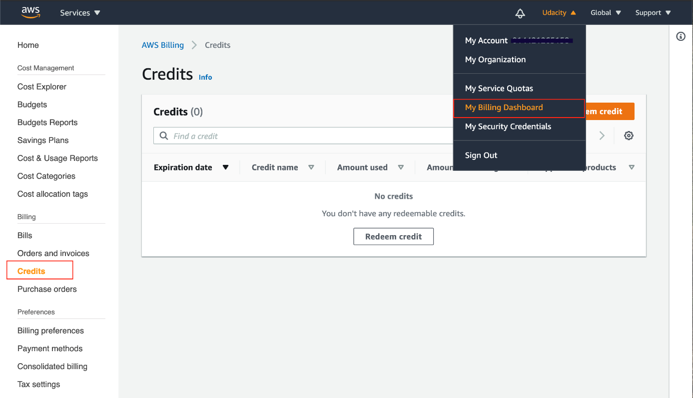

Snapshot: **Credits** page on the **Billing Dashboard**

### AWS Free Tier

It is an offering from AWS that allows you to use most of the AWS services free of cost up to a certain usage limit for one year. In addition to the promo codes provided by Udacity, you can also leverage the [**AWS Free Tier Access**](https://aws.amazon.com/premiumsupport/knowledge-center/what-is-free-tier/).

According to AWS:

The AWS Free Tier is automatically activated on each new AWS account.

Check the list of services covered under Free Tier [**here**](https://aws.amazon.com/free/?all-free-tier.sort-by=item.additionalFields.SortRank&all-free-tier.sort-order=asc&awsf.Free%20Tier%20Types=*all).

**Note** - You will be responsible for charges incurred from usage that exceeds the AWS Free Tier limits and credits provided by Udacity.

5: Monitor your AWS costs and Credits

Link:

Notes:

## Monitoring your AWS Costs and Credits

All AWS services are a pay-as-you-go service, so we urge our students to closely monitor their usage costs and if they have adequate credits available to complete their project/task. Follow the instructions below to do that:

### Step 1. Log into your [AWS account](https://console.aws.amazon.com/).

### Step 2. Examine your costs

Go to [**https://console.aws.amazon.com/billing/**](https://console.aws.amazon.com/billing/)

You should see the following billing dashboard where it will show your costs.

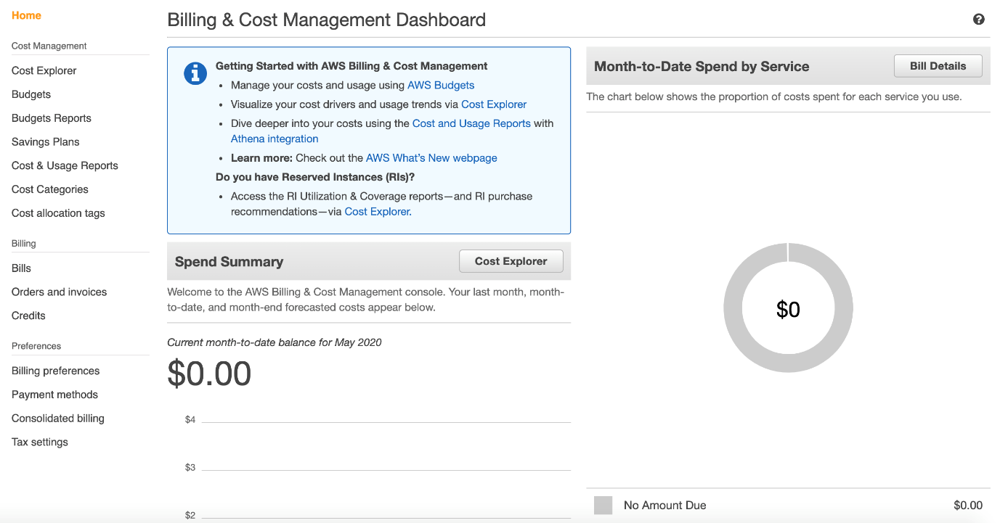

Snapshot: [**AWS Billing Dashboard**](https://console.aws.amazon.com/billing/home#/)

If your account has been created within one year from the current date, your [**AWS Billing Dashboard**](https://console.aws.amazon.com/billing/home#/) will also show the resource usage statistics for the free tier services. See the snapshot below:

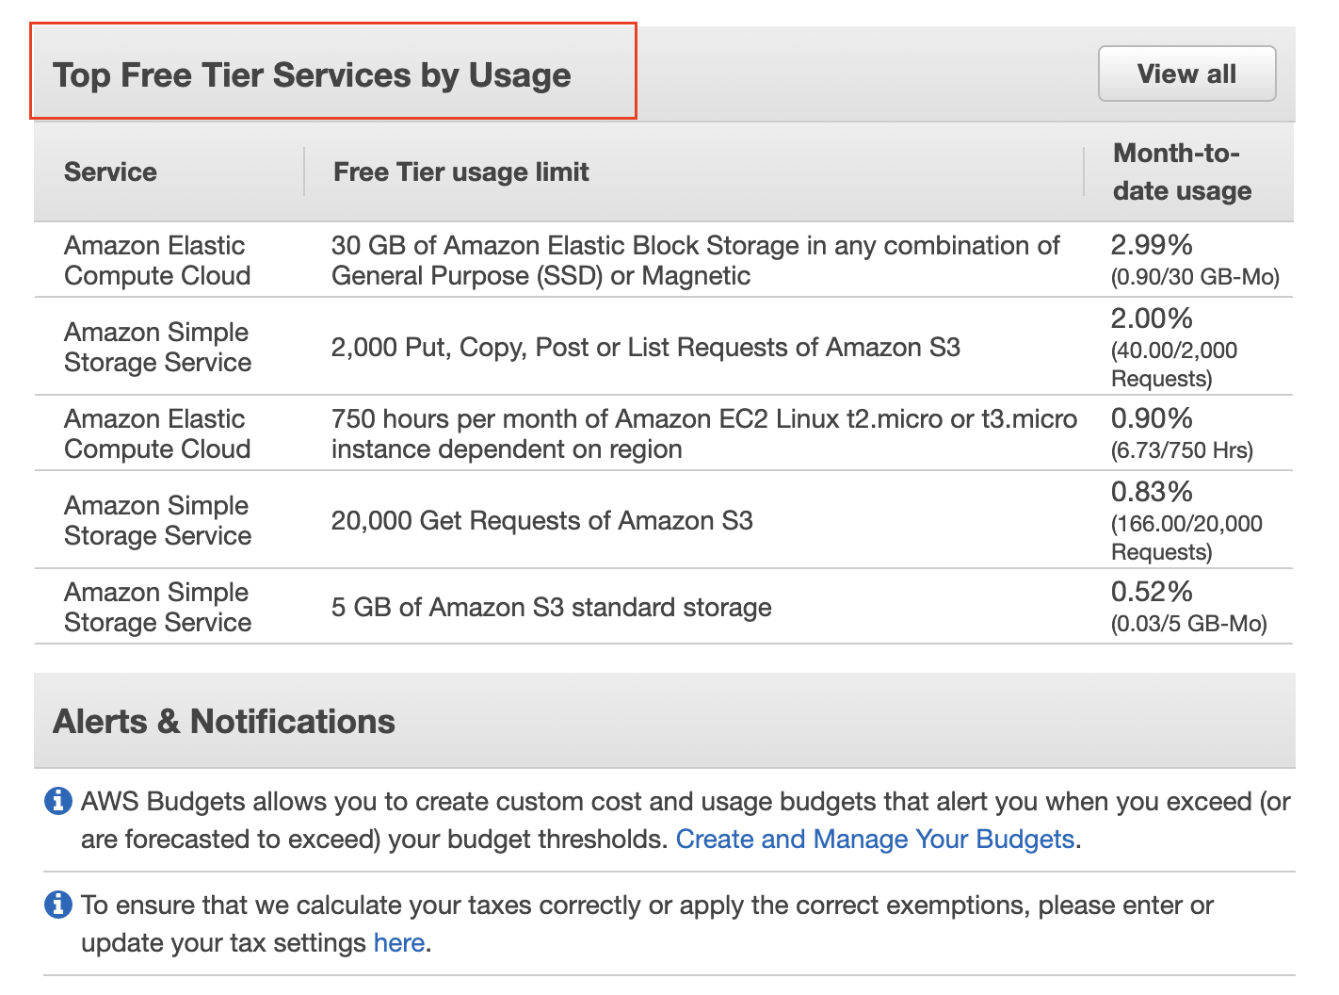

Snapshot: Resource usage statistics for top-free tier services.

### Step 3 (optional). Check the value of your credits.

Click on the "Credits" from the left navigation menu, and the following screen will show your available credits.

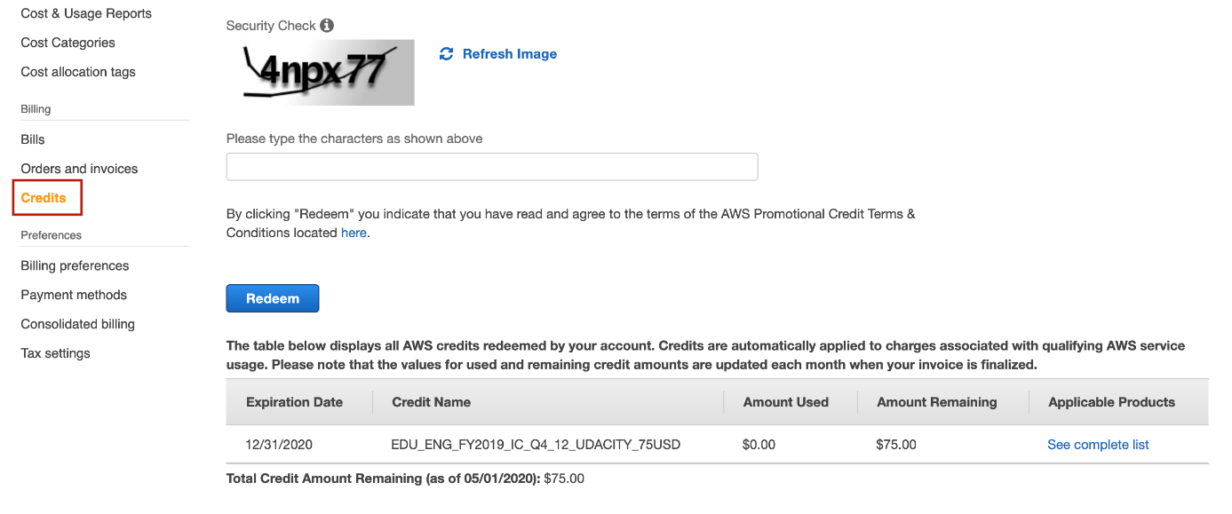

Snapshot: Track credit (promo-code) balance

***Note: For student learning, Udacity has partnered with Amazon to provide nominal credits for the student to complete their course work. Please understand that these credits are limited and available for you to use judiciously. You are responsible for any additional costs beyond the given credits.***

## When will I be charged?

There are no tools to limit usage to what’s covered by the AWS Free Tier. This means that you are responsible for the services that you launch. You will be charged standard [**pay-as-you-go service rates**](https://aws.amazon.com/pricing/) for using AWS resources that exceed the AWS Free Tier limits and the credits provided by Udacity.

## Shut Down your Resources, if not in use

The Free Tier benefits and the credit amount provided by the Udacity Support team will be sufficient for you to complete your Nanodegree program.

#### Note: We recommend you shut down every resource (e.g., EC2 instances, or any other hosted service) on the AWS cloud immediately after the usage, otherwise you will run out of your free promo credits.

Remember, even if you are in the middle of the project and need to step away, PLEASE SHUT DOWN YOUR RESOURCES. You can re-instantiate later.

6: Create an IAM role

Link:

Notes:

# Create an IAM Role

Here, you'll create an IAM role that you will later attach to your Redshift cluster to enable your cluster to load data from Amazon S3 buckets. Read more about IAM roles and Redshift [**here**](https://docs.aws.amazon.com/redshift/latest/gsg/rs-gsg-create-an-iam-role.html).

1. Sign in to the AWS Management Console and open the IAM console at [**https://console.aws.amazon.com/iam/**](https://console.aws.amazon.com/iam/).
2. In the left navigation pane, choose **Roles**.
3. Choose **Create role**.

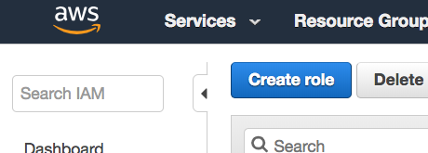

1. In the **AWS Service** group, choose **Redshift**.
2. Under **Select your use case**, choose **Redshift - Customizable**, and then **Next: Permissions**.

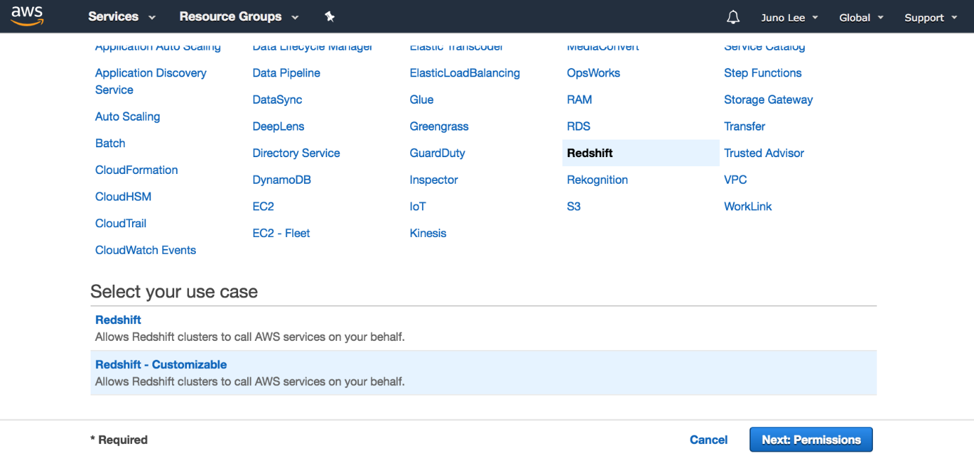

1. On the **Attach permissions policies** page, choose **AmazonS3ReadOnlyAccess**, and then choose **Next: Tags**.
2. Skip this page and choose **Next: Review**.

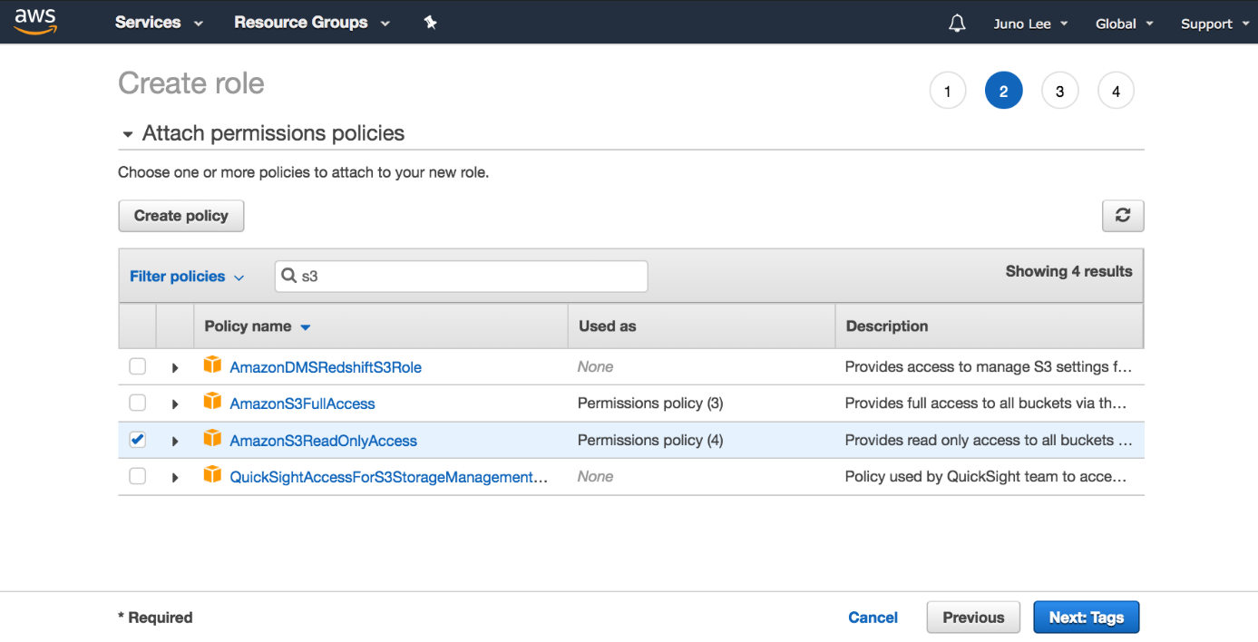

1. For **Role name**, enter myRedshiftRole, and then choose **Create Role**.

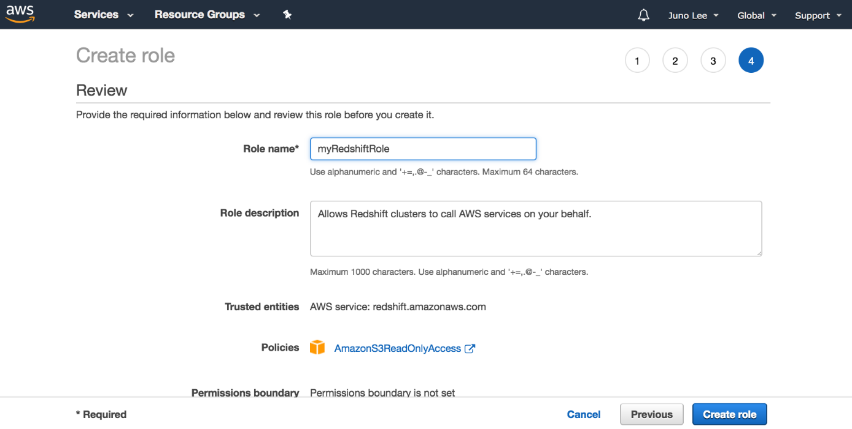

You can now attach this role when you launch a new cluster or attach it to an existing cluster. In the next page, you'll attach the role to a new cluster.

7: Create security group

Link:

Notes:

# Create Security Group

Here, you'll create a security group you will later use to authorize access to your Redshift cluster.

1. Go to your [**Amazon EC2 console**](https://console.aws.amazon.com/ec2) and under **Network and Security** in the left navigation pane, select **Security Groups**.
2. Choose the **Create Security Group** button.

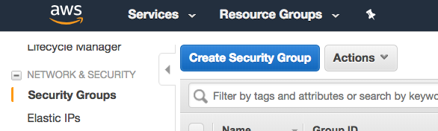

1. Enter redshift_security_group for **Security group name**.
2. Enter "authorize redshift cluster access" for **Description**.
3. Select the **Inbound** tab under **Security group rules**.
4. Click on **Add Rule** and enter the following values:
   * **Type**: Custom TCP Rule.
   * **Protocol**: TCP.
   * **Port Range**: 5439. The default port for Amazon Redshift is 5439, but your port might be different. See note on determining your firewall rules on the earlier "AWS Setup Instructions" page in this lesson.
   * **Source**: select Custom IP, then type 0.0.0.0/0.

**Important: Using 0.0.0.0/0 is not recommended for anything other than demonstration purposes because it allows access from any computer on the internet.** In a real environment, you would create inbound rules based on your own network settings.

1. Choose **Create**.

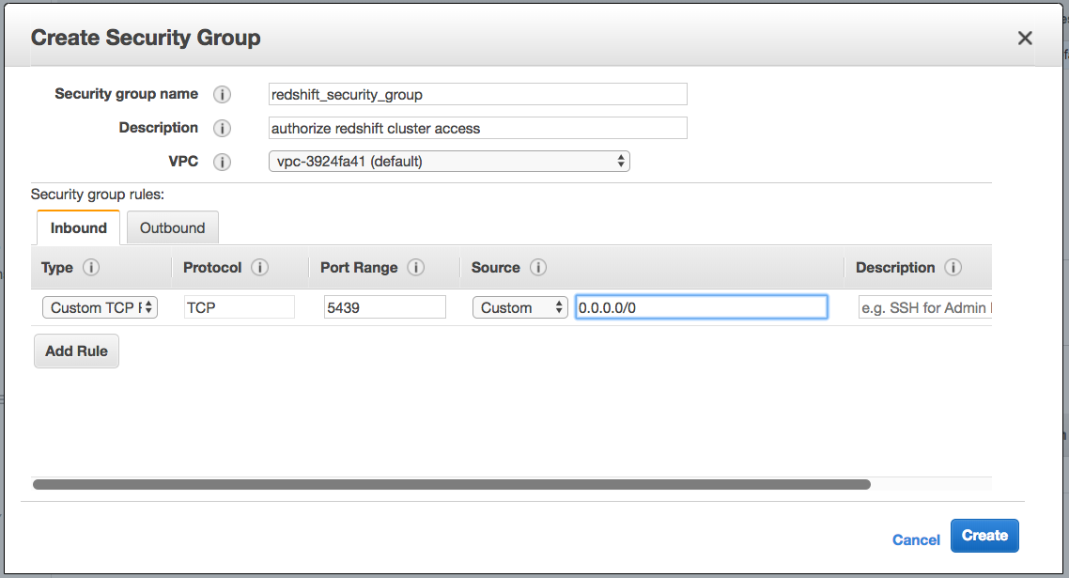

NEXT

8: Launch a Redshift Cluster

Link:

Notes:

# Launch a Redshift Cluster

**WARNING:** The cluster that you are about to launch will be live, and you will be charged the standard Amazon Redshift usage fees for the cluster until you delete it. **Make sure to delete your cluster each time you're finished working to avoid large, unexpected costs for yourself.** Instructions on deleting your cluster are included on the last page in this lesson. You can always launch a new cluster, so don't leave your Redshift cluster running overnight or throughout the week if you don't need to.

1. Sign in to the AWS Management Console and open the Amazon Redshift console at [**https://console.aws.amazon.com/redshift/**](https://console.aws.amazon.com/redshift/).
2. On the Amazon Redshift Dashboard, choose **Launch cluster**.

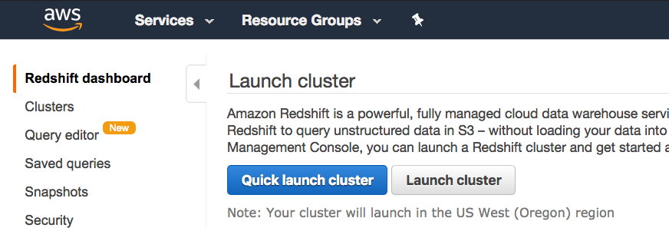

1. On the Cluster details page, enter the following values and then choose Continue:
   * **Cluster identifier**: Enter redshift-cluster.
   * **Database name**: Enter dev.
   * **Database port**: Enter 5439.
   * **Master user name**: Enter awsuser.
   * **Master user password** and **Confirm password**: Enter a password for the master user account.

**Please note:** We **strongly advise** you to keep these passwords closely guarded, including not putting them in your GitHub public repo, etc.

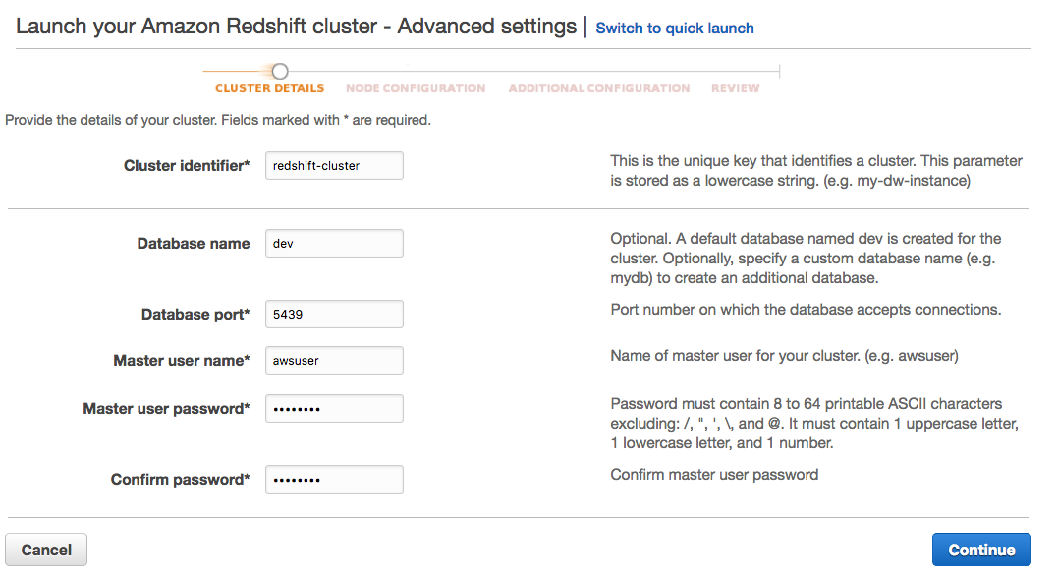

1. On the Node Configuration page, accept the default values and choose **Continue**.

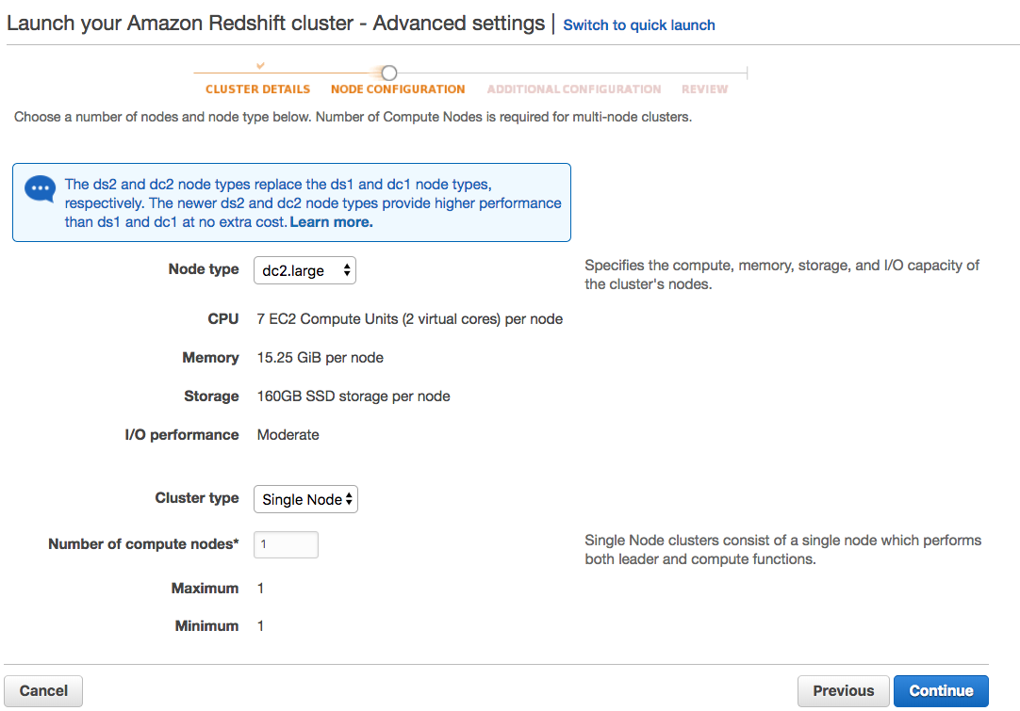

1. On the Additional Configuration page, enter the following values:
   * **VPC security groups**: redshift_security_group
   * **Available IAM roles**: myRedshiftRole

Choose **Continue**.

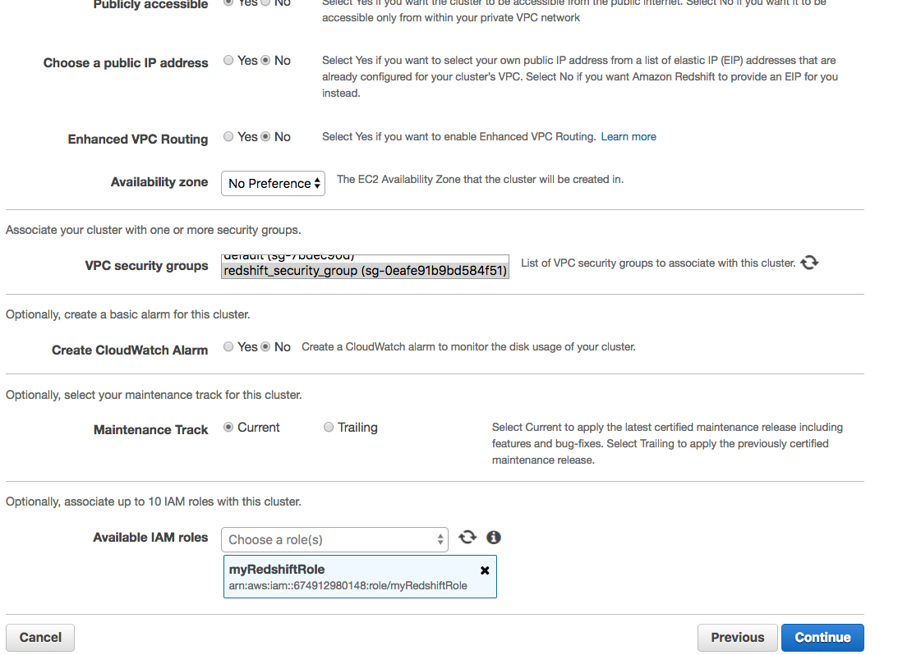

1. Review your Cluster configuration and choose **Launch cluster**.

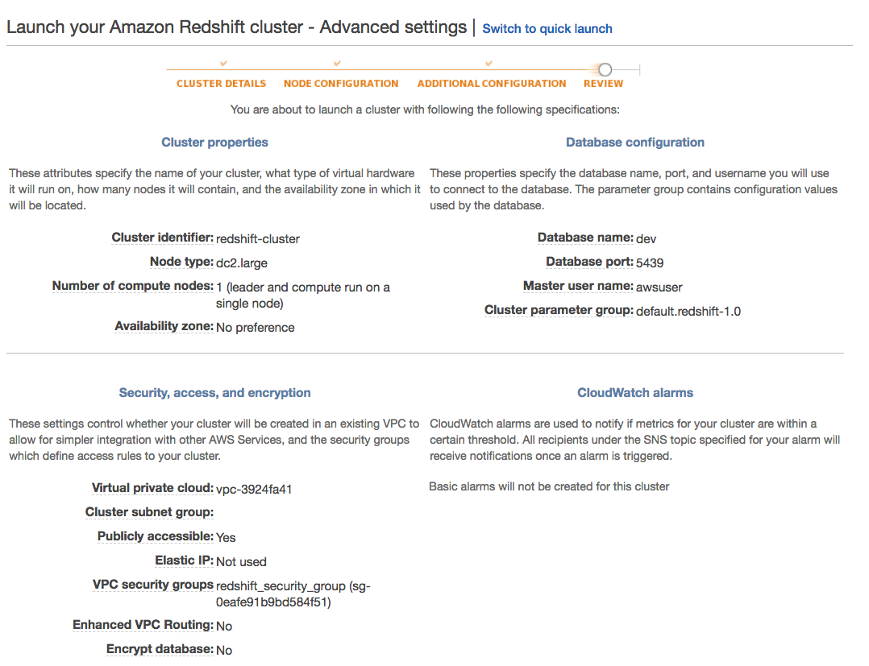

https://video.udacity-data.com/topher/2019/February/5c5b2dd2_review-cluster-launch/review-cluster-launch.png

1. A confirmation page will appear and the cluster will take a few minutes to finish. Choose **Clusters** in the left navigation pane to return to the list of clusters.

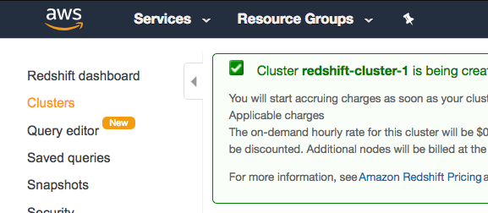

1. On the Clusters page, look at the cluster that you just launched and review the **Cluster Status** information. Make sure that the **Cluster Status** is **available** and the **Database Health** is **healthy** before you try to connect to the database later. You can expect this to take 5-10 minutes.

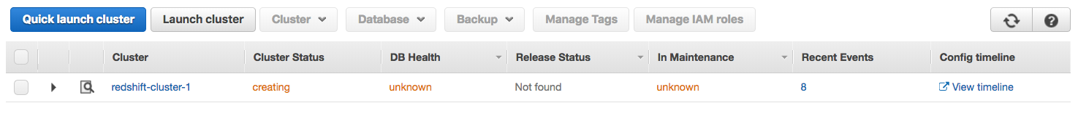

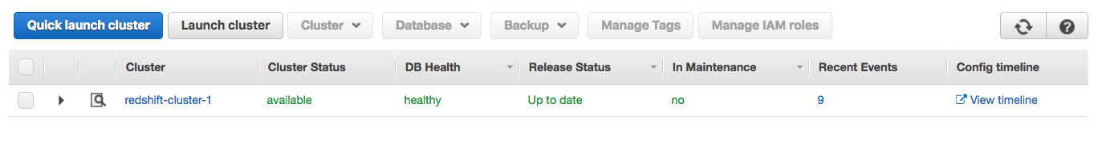

9: Create an IAM user

Link:

Notes:

# Create an IAM User

Here, you'll create an IAM user that you will use to access your Redshift cluster.

1. Sign in to the AWS Management Console and open the IAM console at [**https://console.aws.amazon.com/iam/**](https://console.aws.amazon.com/iam/).
2. In the left navigation pane, choose **Users**.
3. Choose **Add User**.

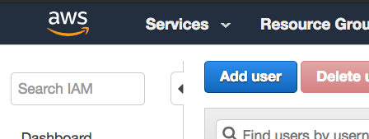

1. Enter a name for your user (e.g. airflow_redshift_user)
2. Choose **Programmatic access**, then choose **Next: Permissions**.

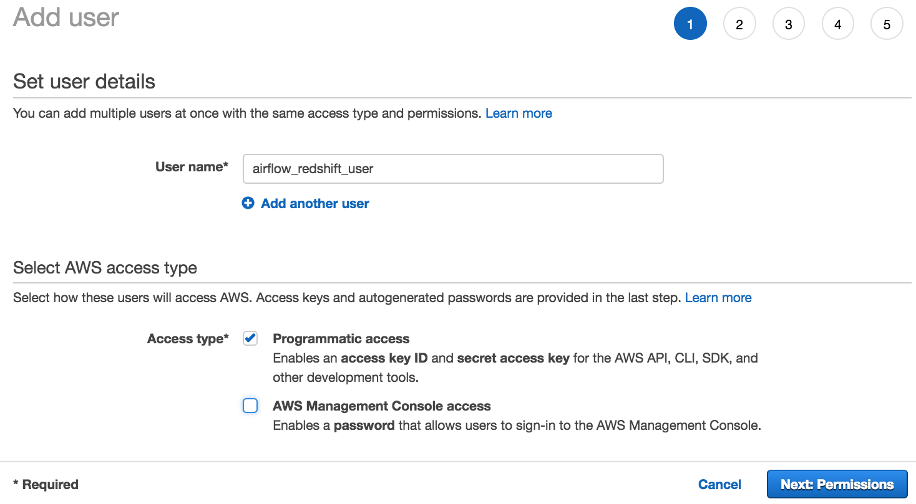

1. Choose **Attach existing policies directly**.
2. Search for redshift and select **AmazonRedshiftFullAccess**. Then, search for S3 and select **AmazonS3ReadOnlyAccess**. After selecting both policies, choose **Next: Tags**.
3. Skip this page and choose **Next: Review**.

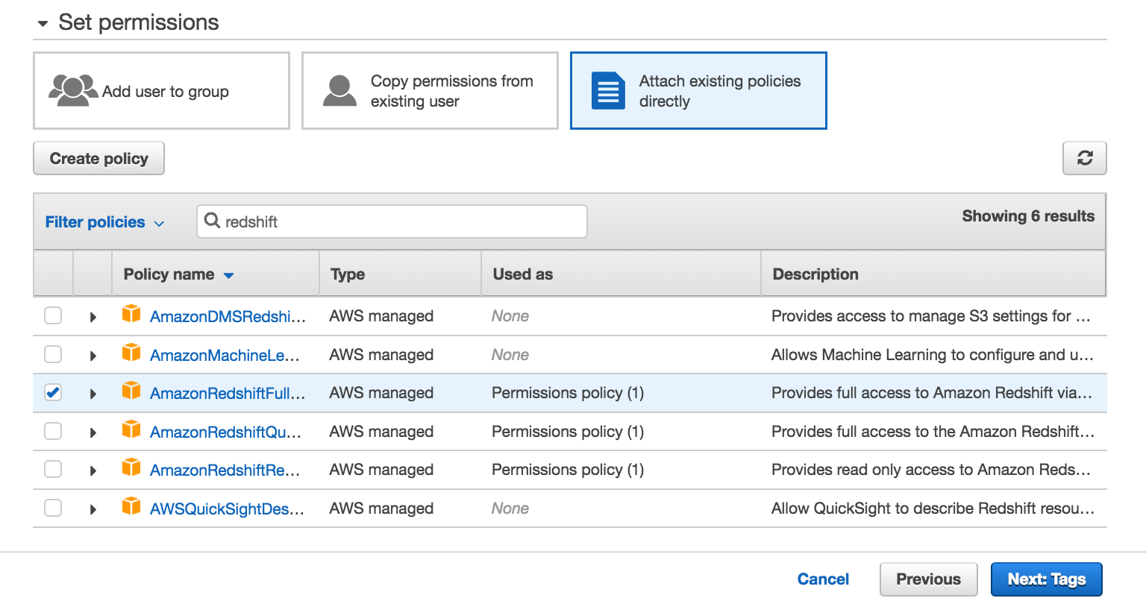

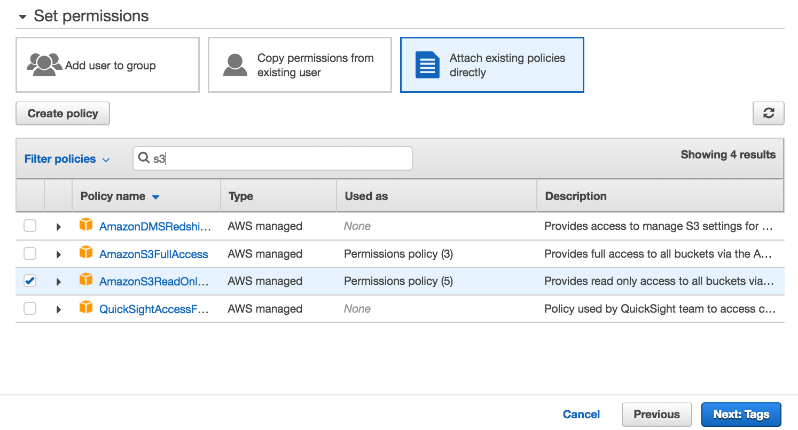

1. Review your choices and choose **Create user**.

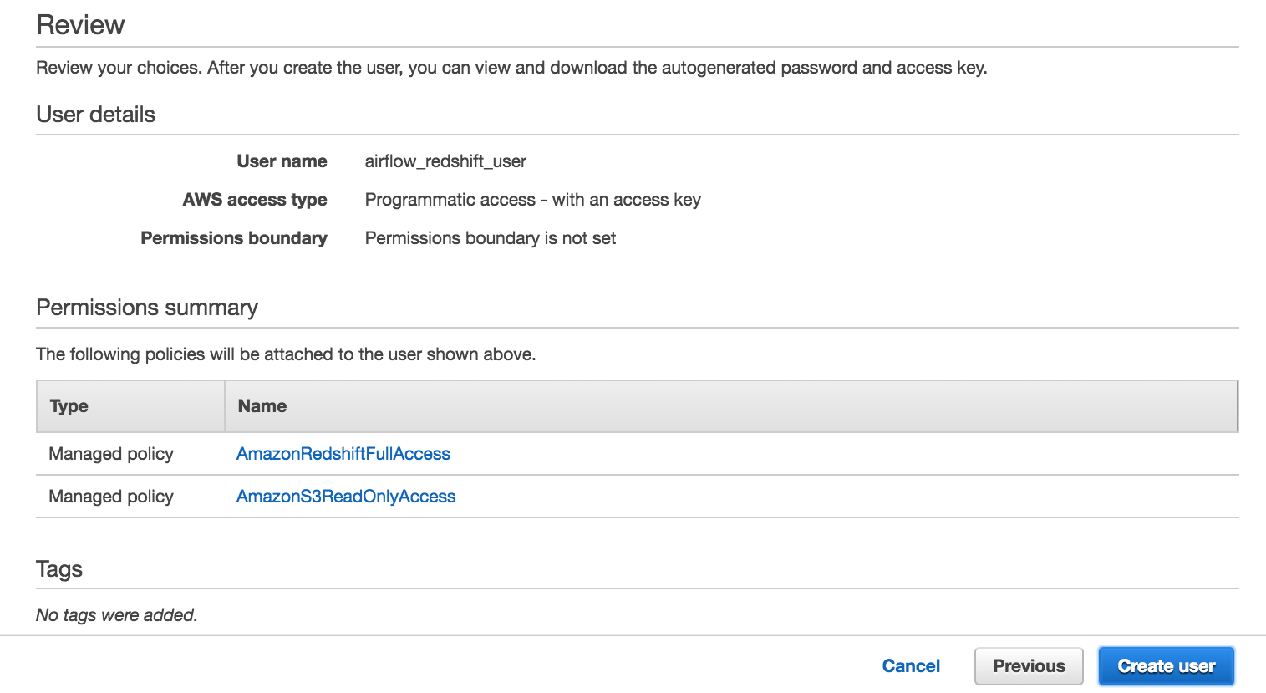

1. **Save your credentials!** This is the only time you can view or download these credentials on AWS. Choose **Download .csv** to download these credentials and then save this file to a safe location. You'll need to copy and paste this **Access key ID** and **Secret access key** in the next step.

We **strongly advise** you to keep this **Access key ID** and **Secret access key** closely guarded, including not putting them in a GitHub public repo, etc.

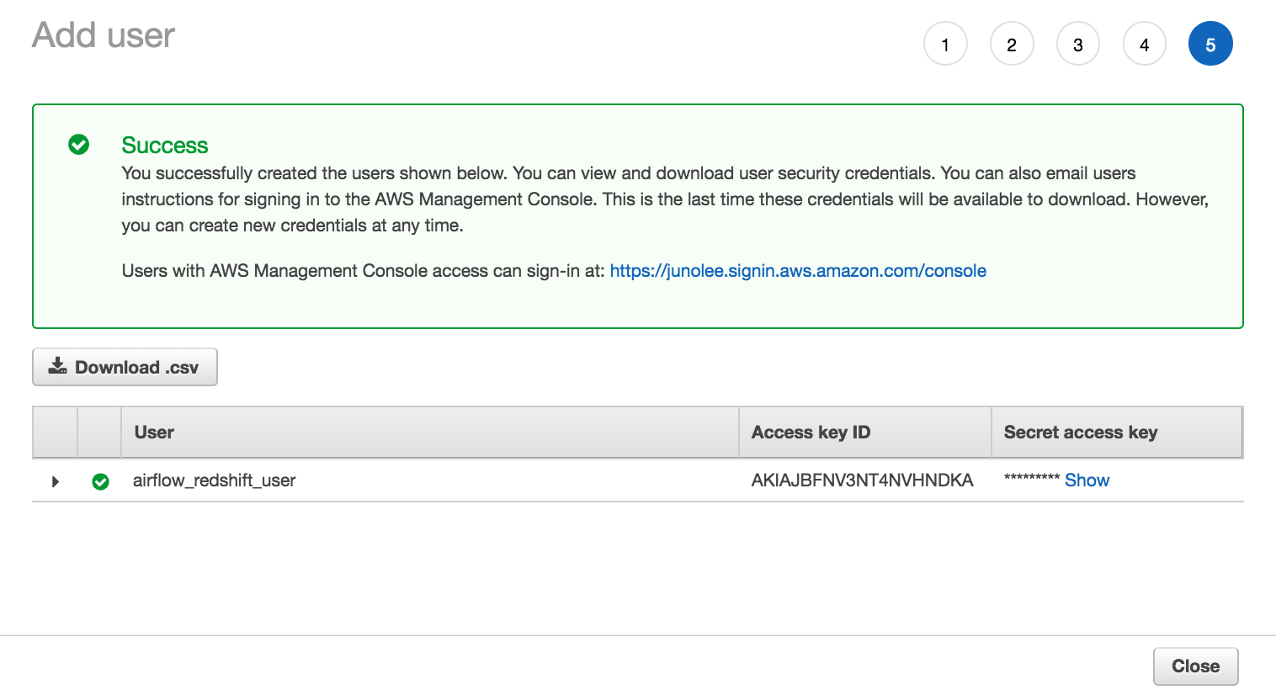

As of June 2020, the AWS Management Console's UI has slightly changed. You can find the updated documentation on IAM roles [**here**](https://docs.aws.amazon.com/IAM/latest/UserGuide/id_roles.html).

10: Delete a Redshift Cluster

Link:

Notes:

**Delete a Redshift Cluster**

Make sure to delete your cluster each time you're finished working to avoid large, unexpected costs. You can always launch a new cluster, so don't leave it running overnight or throughout the week if you don't need to.

1. On the **Clusters** page of your Amazon Redshift console, click on the box next to your cluster to select it, and then click on **Cluster** > **Delete cluster**.

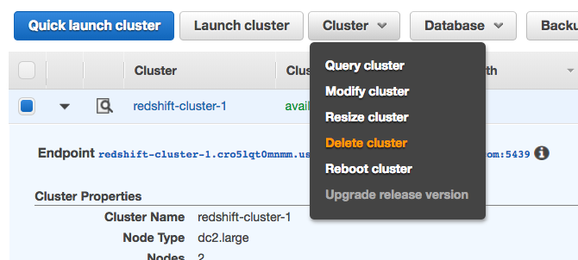

1. You can choose **No** for **Create snapshot**, check the box that you acknowledge this, and then choose **Delete**.

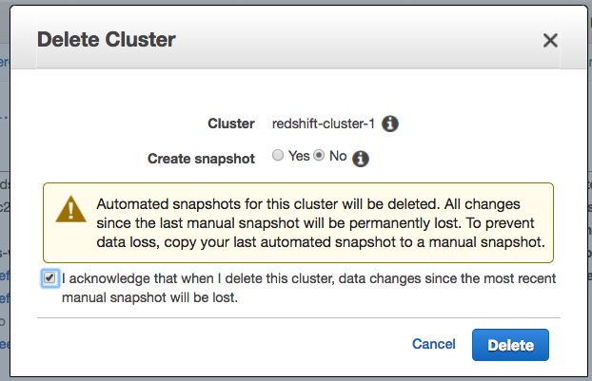

1. Your cluster will change it's status to **deleting**, and then disappear from your Cluster list once it's finished deleting. You'll no longer be charged for this cluster.

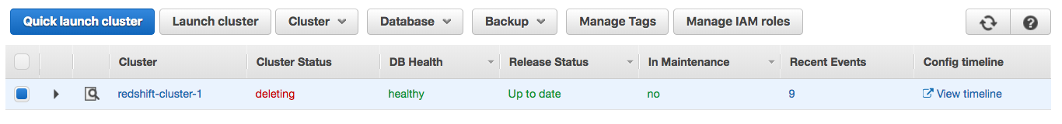

11: Create Postgres RDS

Link:

Notes:

# Create a PostgreSQL DB Instance using RDS

1. Go to the [**Amazon RDS console**](https://console.aws.amazon.com/rds/) and click on **Databases** on the left navigation pane. Choose what region you'd like to create this database in on the right of the top menu bar.
2. Click on the **Create Database** button.

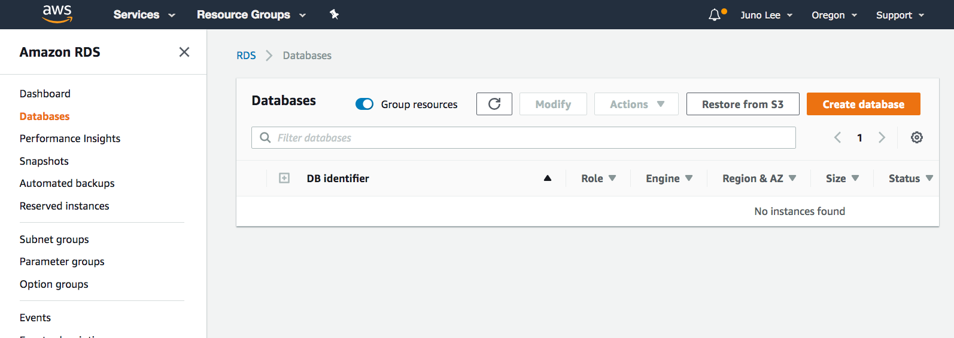

1. Select **PostgreSQL** on the Select Engine page.

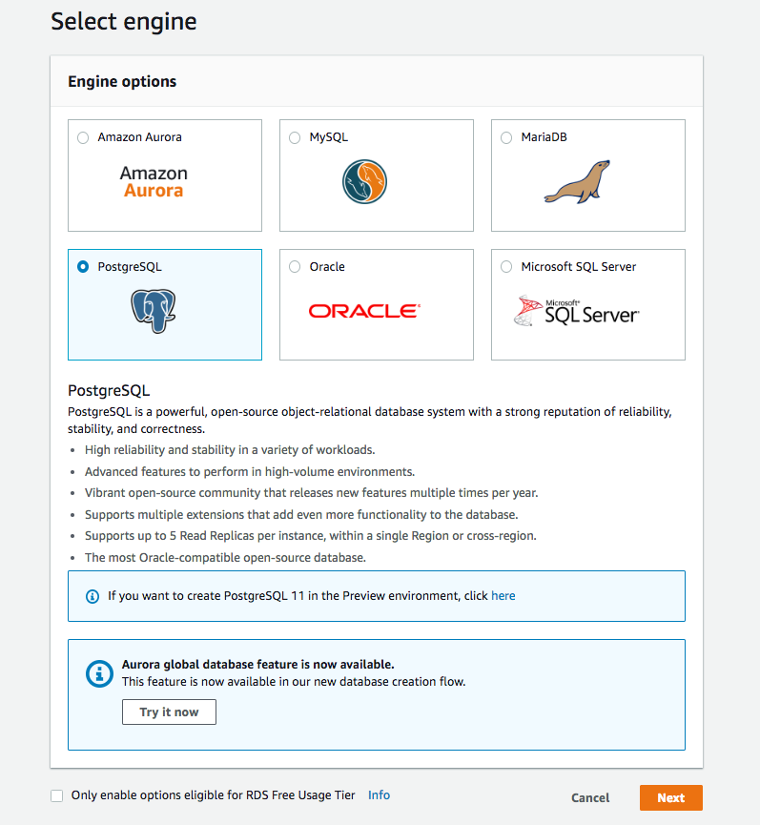

1. Since this is for demonstration purposes, select **Dev/Test** under Use case.

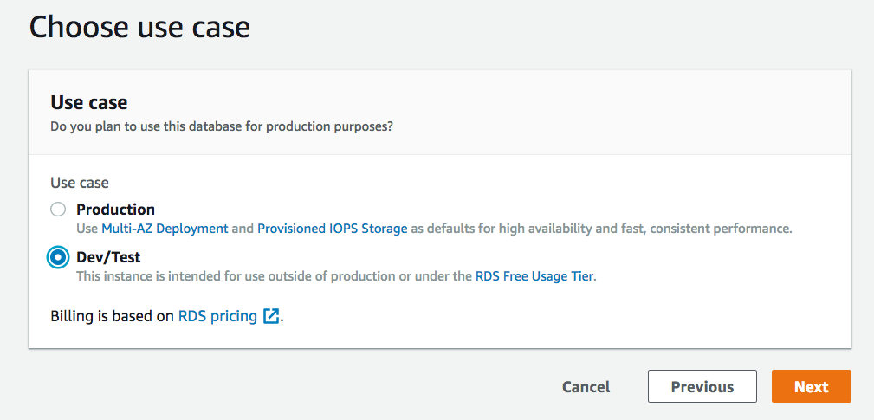

1. Next, is a long **Specify DB details** page. You can leave the default values (shown below) for most of these settings. Just make the following choices:
   * For **DB instance class**, select db.t2.small

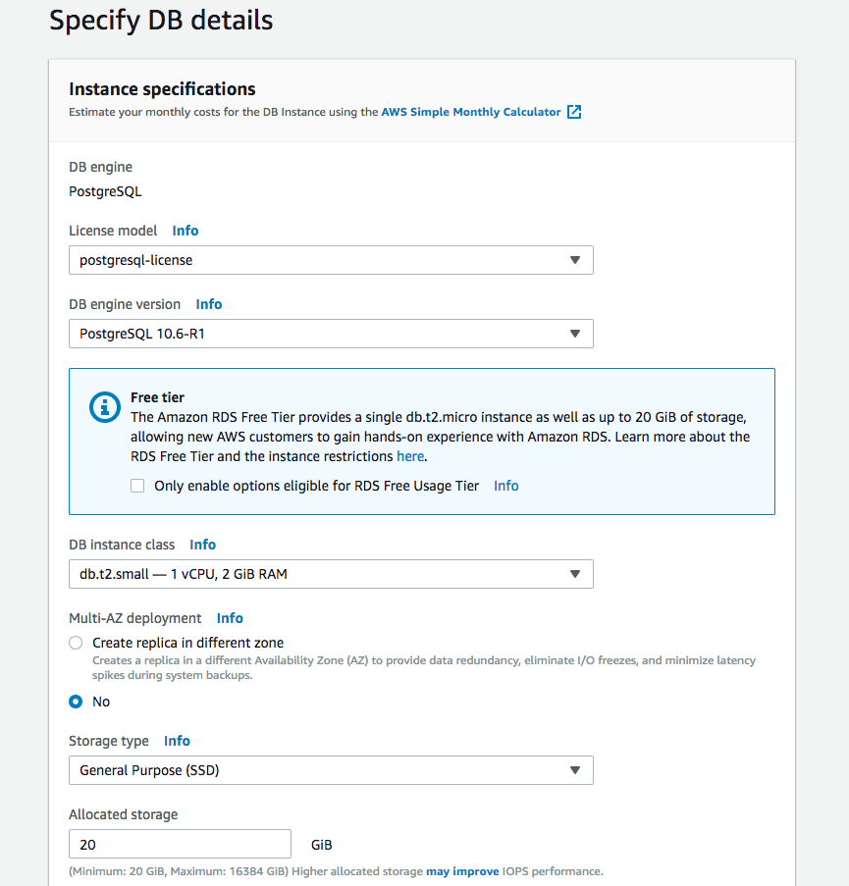

* For DB instance identifier, enter postgreSQL-test or another name of your choice
* Enter a master username and password

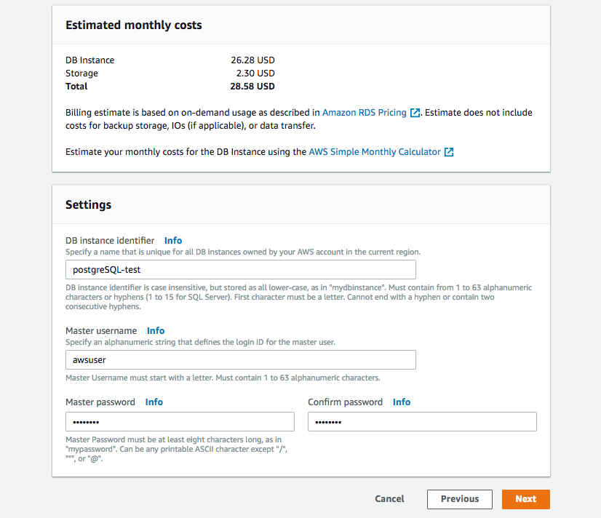

* Leave the default values for the next few sections.

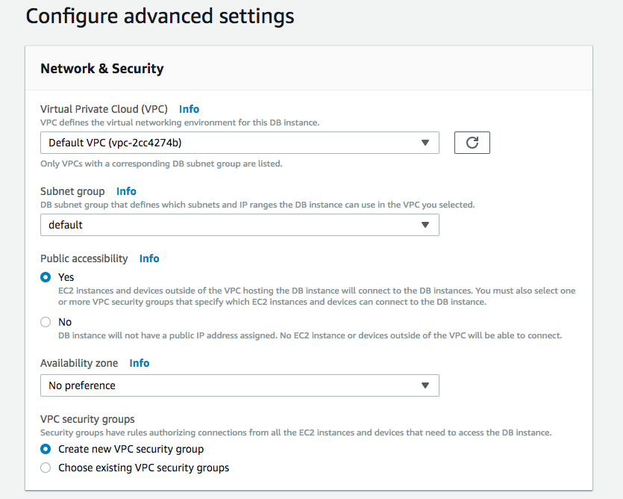

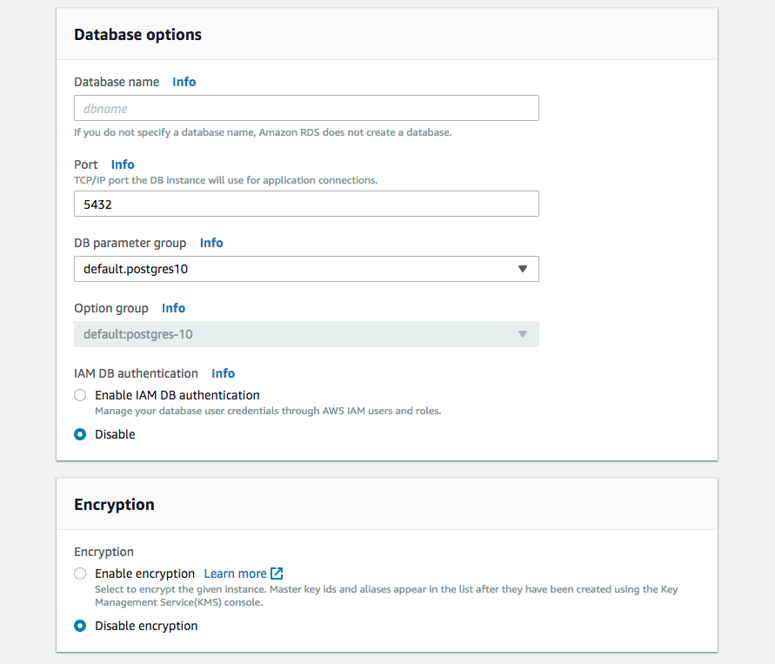

* In the **Backup** section and select 1 day since this is for demonstration purposes.

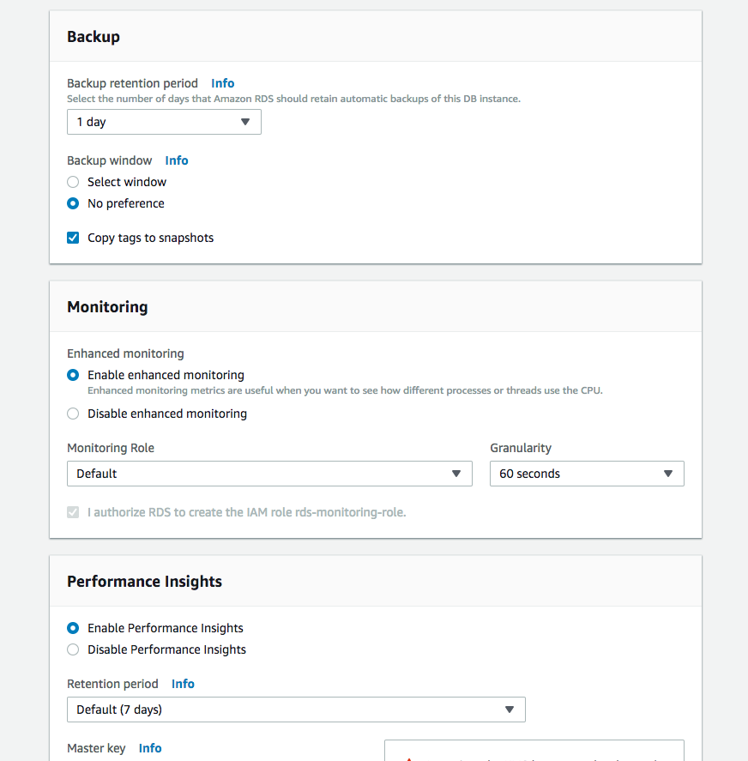

* Leave the default values for the rest and click on **Create database** on the bottom right.

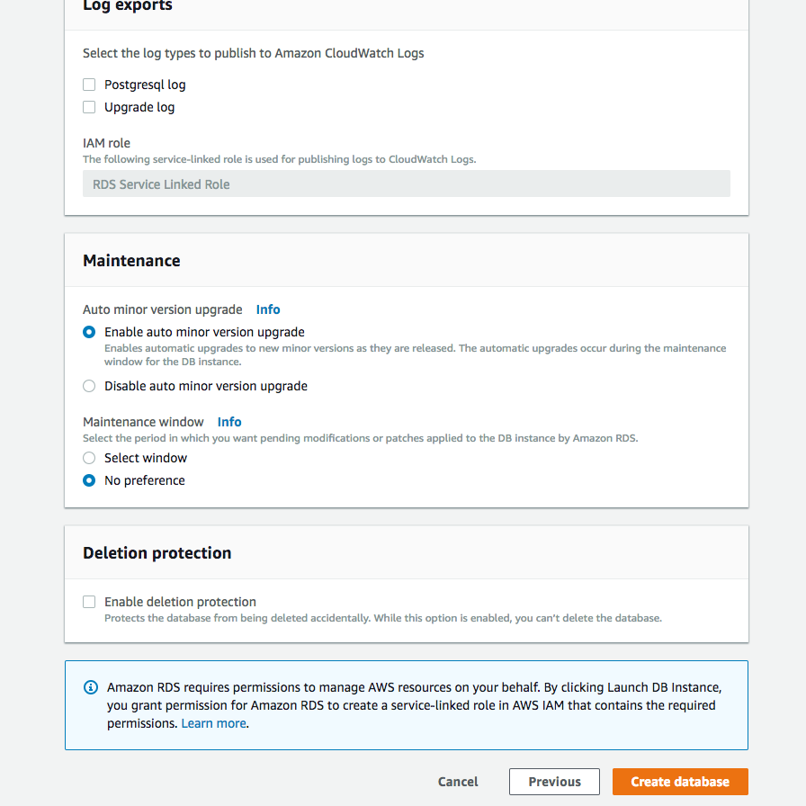

You should land on a confirmation page.

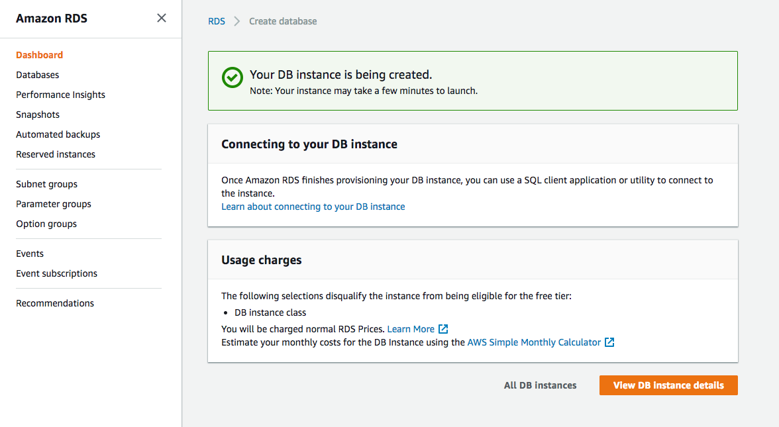

1. Click **Databases** on the left navigation pane to return to your list of databases. You should see your newly created database with the status **Creating**.

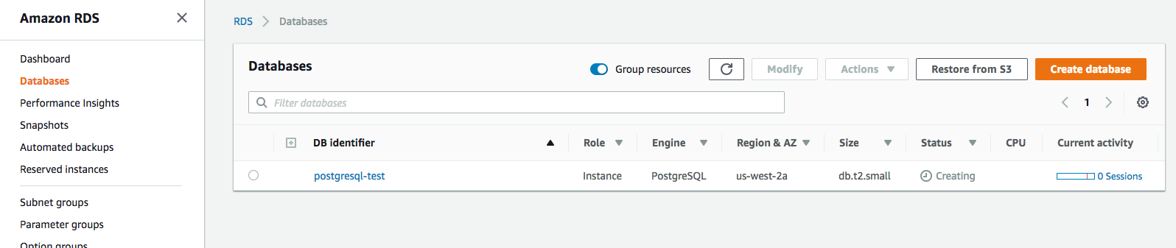

1. Wait a few minutes for this to change to the status **Available**.

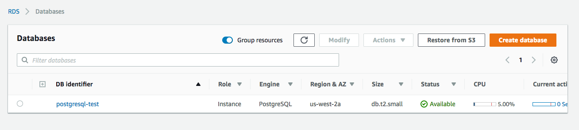

12: Avoid Paying Unexpected Costs For AWS

Link:

Notes:

### Important Note

We believe that the amount of AWS Educate promotional credits we have arranged for Udacity students to receive for free from AWS is sufficient to allow you to complete all of your work in the Data Engineering ND, if you follow the guidelines we provide in this lesson for using your credits wisely.

#### Key recommendations for using your AWS credits wisely:

* Delete your Amazon Redshift cluster each time you're finished working.
* Use a smaller subset of your data while you code and debug on AWS, and only execute with the full dataset on AWS as a final test of your code.

**If you exceed the AWS credits that you are provided, you will be responsible for purchasing any additional credits necessary to complete the Nanodegree.** Students are solely responsible for monitoring usage charges on the AWS account you use.

If you believe there is an error or problem with your usage of AWS credits, please contact AWS Support at [**https://console.aws.amazon.com/support/home**](https://console.aws.amazon.com/support/home).

For more information or inquiries, please refer to the [**AWS Educate Terms and Conditions**](https://www.awseducate.com/registrationtandc).